**DAILY ONLINE ACTIVITIES SUMMARY**

|  |  |  |  |  |  |
| --- | --- | --- | --- | --- | --- |
| **Date:** | | **02/07/2020** | **Name:** | **JASLINE SHARON TAURO** | |
| **Sem & Sec** | | **4th sem, A Section** | **USN:** | **4AL18CS029** | |
| **Online Test Summary** | | | | | |
| **Subject** | **-------** | | | | |
| **Max. Marks** | **--** | | **Score** | **--** | |
| **Certification Course Summary** | | | | | |
| **Course** | | CLOUD SUPPORT ENGINEER | | | |
| **Certificate Provider** | | **AWS Educate** | **Duration** | | **4 hrs.** |
| **Coding Challenges** | | | | | |
| **Problem Statement:**  Write a Java Program minimize the maximum difference between adjacent elements in an array. | | | | | |
| **Status: EXECUTED** | | | | | |
| **Uploaded the report in GitHub** | | | **YES** | | |
| **If yes Repository name** | | | <https://github.com/jaslinesharontauro/JAVA_Prgms> | | |
| **Uploaded the report in slack** | | | **YES** | | |

Online Test Details: (Attach the snapshot and briefly write the report for the same)

Certification Course Details: (Attach the snapshot and briefly write the report for the same)

Coding Challenges Details: (Attach the snapshot and briefly write the report for the same)

CERTIFICATION COURSE DETAILS:

Today I have continued the course “Cloud Support Engineer” by AWS Educate. In this course today I learnt about ‘Security’. Today I have completed one module of this course, And I have also completed the final assessment and final project of this course. Also I have received a Badge for completion of this course.

## 

## 

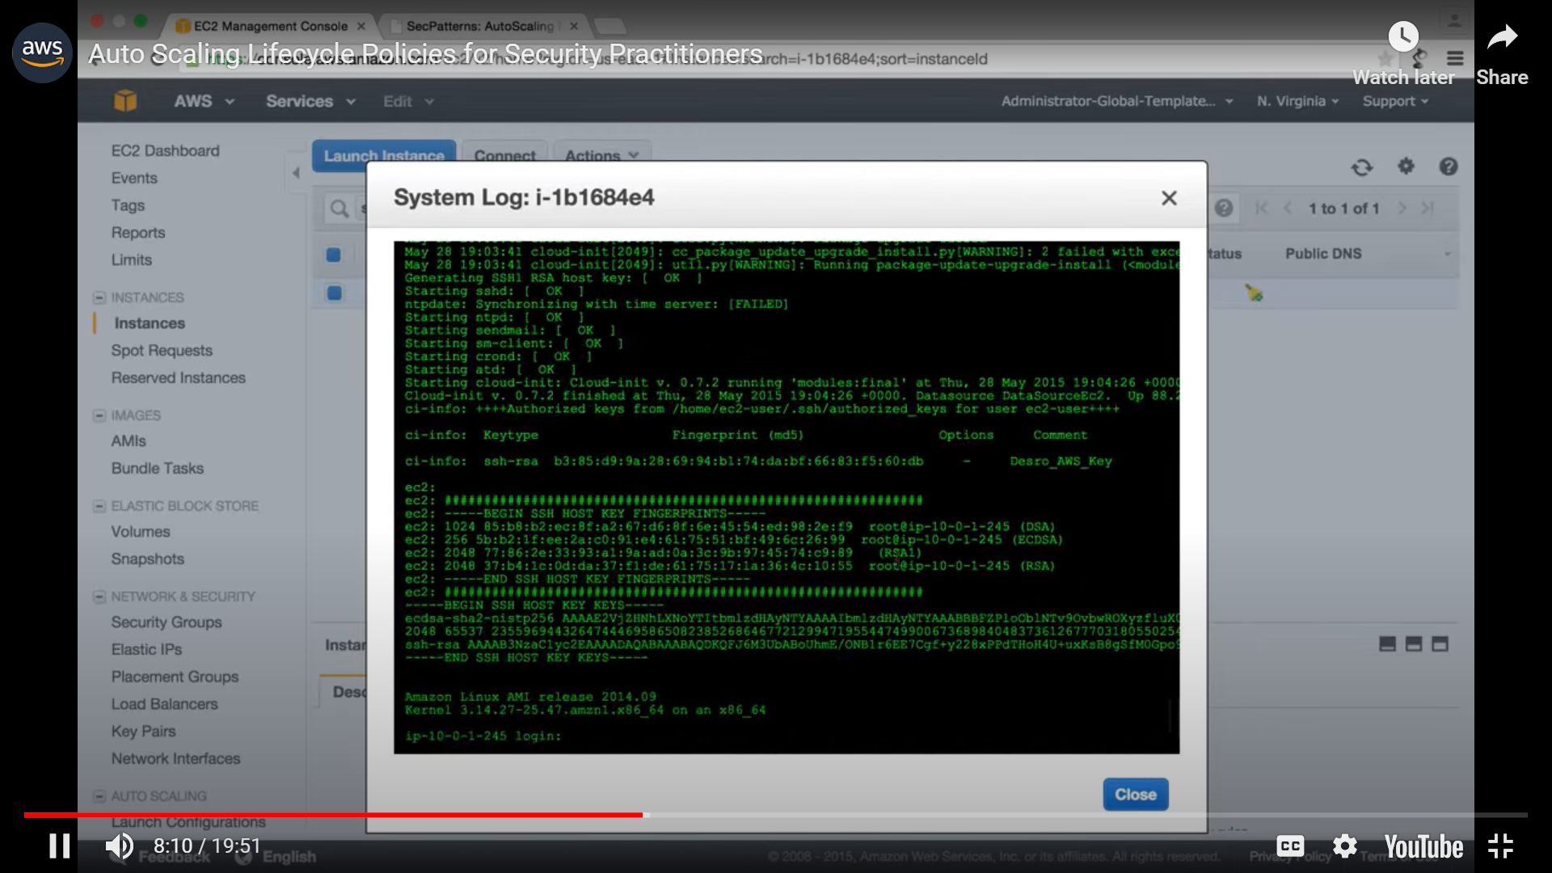



**WEBINAR DEAILS:**

**Today I attended a webinar on “Constructor Destructor, Inheritance, Polymorphism” by Assistant professor Ms. Shruthi Shetty J. The session was very interesting. There was an quiz conducted based on the webinar, I scored 20/30.**

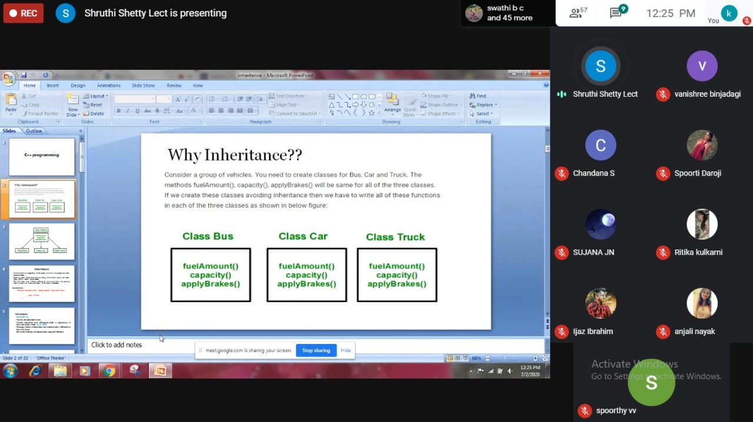

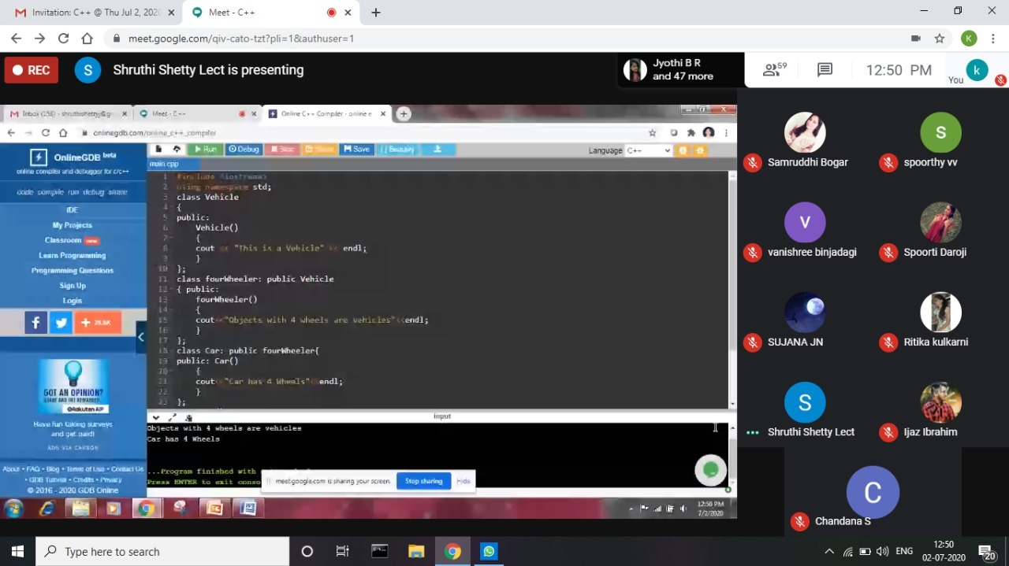

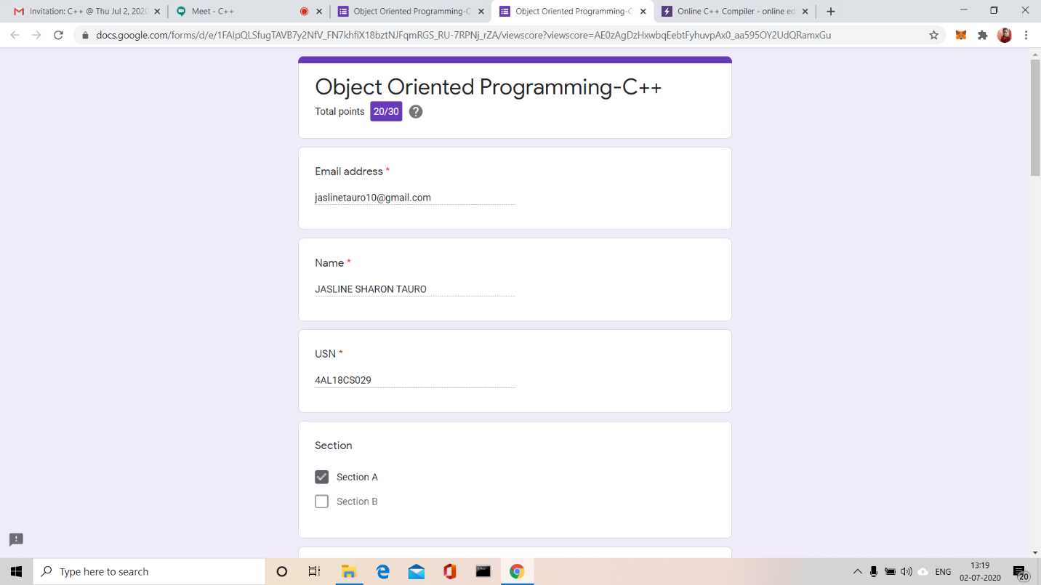

**CODING CHALLENGES:**

Write a Java Program minimize the maximum difference between adjacent elements in an array.

Given a non-decreasing array arr[] and an integer K, the task is to remove K elements from the array such that maximum difference between adjacent element is minimum.

Note: K < N – 2

Examples:

Input: arr [] = {3, 7, 8, 10, 14}, K = 2  
Output: 2  
Explanation:  
After removing elements A[0] and A[4],

The maximum difference between adjacent elements is minimum.  
After removing elements, the remaining array is [7, 8, 10]

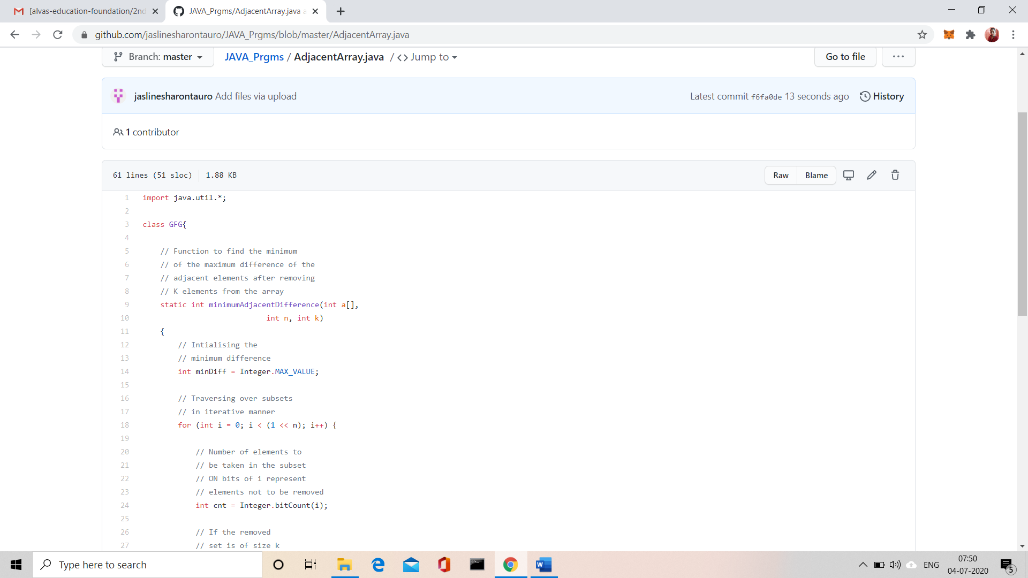

**Solution:** Uploaded it in GitHub